**[EcoAnalyser](https://www.mixo.io/site/eco-analyser-0diz5)**

**Leading the Organic and Green Revolution.**

**Providing Sustainable Solutions for Agriculture, Energy and the Environment. Sale of handheld tools in Food and Environmental safety. Representatives and Brokers in analytical equipment**

**Call 234 8050237257(Watsapp) or rhizucor@gmail.com**

**“AGRO-ENERGY BROKERS has been instrumental in helping us transition to sustainable energy and farming practices. We have seen real results and savings since working with them.”**

**Emma Locatellli**

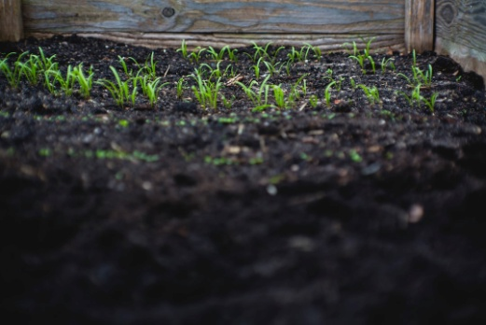

**"Thanks to the expertise and resources of AGRO-ENERGY BROKERS, we have been able to better conduct our research and analysis. They provide a top-notch service with great attention to detail."**

Peter King

**Join the green revolution with AGRO-ENERGY BROKERS today.**